2. A Method to Solve Boolean Expression for given inputs

2.1 Program:

/* Program to solve the given Boolean expression for given c outputs */

#include"stdio.h"
#include"ctype.h"
#include"string.h"
#include"math.h"

void main(void)
{
clrscr();

takeinputs();

getvalandsolve();

clrscr();
gotoxy(35,13);printf("Thank U");
getch();
}

char expr[100]=""; /* Array to hold the input expression */
char var[100][10]={""}; /* Array to hold the input variables */
int cou=0; /* Counter to hold the count of the variables */

takeinputs(void)
{
int len; /* Variable to hold the length of the input expression */
int i,j; /* Loop counters */

/* Introduction notes for this application */
gotoxy(23,8);printf("Operations Symbols");
gotoxy(23,10);printf("==========================================");
gotoxy(23,12);printf("AND . ");
gotoxy(23,14);printf("OR + ");
gotoxy(23,16);printf("NEGATION ` ");
gotoxy(23,18);printf("PARANTHESIS ()");
gotoxy(40,24);printf("Press any key to continue . . .");
getch();
clrscr();

/* To take the input from the user */
gotoxy(23,12);printf("Enter the Boolean expression :-> ");
gets(expr);

/* To compute the length of the input expression */
len=strlen(expr);

/* To remove spaces in the expression */
for(i=0;i<len;i++)
if(expr[i] == ' ')
{
j=i;
for(;expr[j] != '\0';j++)
expr[j]=expr[j+1];
len=strlen(expr);
}

/* To separate variables from the expression */
for(i=0;i<len;i++)
{
if(isalnum(expr[i]))
{
char temp[10]="";
temp[0]=expr[i];
temp[1]='\0';
strcat(var[cou],temp);
}

if(expr[i] == '.' || expr[i] == '+')
{
cou++;
}
}

/* To sort the variables */
for(i=0;i<=cou;i++)
for(j=i+1;j<=cou;j++)
if(strcmp(var[i],var[j]) > 0)
{
char temp[10]="";
strcpy(temp,var[i]);
strcpy(var[i],var[j]);
strcpy(var[j],temp);
}

/* To eliminate repetitions */
for(i=0;i<=cou;i++)
{
while(!strcmp(var[i],var[i+1]))
{
for(j=i+1;j<=cou;j++)
strcpy(var[j],var[j+1]);
cou--;
}
}

clrscr();

gotoxy(23,12);printf("No of variables are :-> %d\n",cou+1);

gotoxy(23,14);printf("The Variables are :-> ");
for(i=0;i<=cou;i++)
printf("%s ",var[i]);

gotoxy(40,24);printf("Press any key to continue . . .");
getch();
}

int stack[100]={7}; /* Array to act as a stack */
int st=-1; /* Variable to act as stack top */
int andor=0;

getvalandsolve()
{
int i,j,k; /* Loop variables */
int inter[100]={7}; /* To hold intermediate result */
int a[10]={0}; /* To hold the binary format */

for(i=0;i<=cou;)
{
clrscr();
gotoxy(15,12);printf("Enter the value for variable %s:-> ",var[i]);
gotoxy(40,24);printf("Press any key to continue . . .");
gotoxy(48,12);printf(" ");
scanf("%d",&a[i]);

if(a[i] == 1 || a[i] == 0)
i++;
}

andor=0; /* Initialization of precedence controller */

/* To solve the given Boolean expression */
for(j=0;j<strlen(expr);j++)
{
char va[10]="";
if(isalnum(expr[j]))
{
/* To separate variables from the expression*/
for(k=j;isalnum(expr[k]);k++)
{
char te[10]="";
te[0]=expr[k];
te[1]='\0';
strcat(va,te);
}

j=k-1;

/* To place variable inputs behalf of variables */
for(k=0;k<=cou;k++)
if(!strcmp(var[k],va))
if(expr[j+1] == '`')
{
push(nag(a[k]));
j++;
}
else
push(a[k]);
}
else if(expr[j] == '.')
push(2);
else if(expr[j] == '+')
push(3);
else if(expr[j] == '(')
push(4);
else if(expr[j] == ')')
push(5);
else if(expr[j] == '`')
push(6);
}

andor=1; /* Changing the precedence variable */

for(k=0;st != -1;k++)
inter[k]=pop();

for(j=0;j<k;j++)
push(inter[j]);

clrscr();
gotoxy(15,12); printf("The result of the given expression is :-> ");
printf("%d ",pop());
gotoxy(40,24);printf("Press any key to continue . . .");
getch();
}

/* To perform push operation on the stack and to solve the Boolean expression */
push(int temp)
{
if((temp == 2) || (temp == 3))
{
st++;
stack[st]=temp;
}
else if(temp == 5)
{
if(stack[st-1] == 4 && andor == 0)
{
int z=pop();
pop();
push(z);
return;
}
else
{
st++;
stack[st]=temp;
}
}
else if(temp == 4)
{
if(stack[st-1] == 5 && andor == 1)
{
int z=pop();
pop();
push(z);
return;
}
else
{
st++;
stack[st]=temp;
}
}
else if(stack[st] == 2)
{
int z,y;
pop();
z=pop();
y=and(z,temp);
push(y);
return;
}
else if(stack[st] == 3)
{
if(andor == 1)
{
int z,y;
pop();
z=pop();
y=or(z,temp);
push(y);
return;
}
else
{
st++;
stack[st]=temp;
}
}
else if(temp == 6)
{
if(stack[st] != 5 && andor == 0)
{
int z;
z=pop();
push(nag(z));
}
else
{
st++;
stack[st]=temp;
}
}
else
{
if(stack[st] == 6)
{
pop();
push(nag(temp));
}
else
{
st++;
stack[st]=temp;
}
}
}

/* To perform pop operation on the stack */
pop()
{
int temp;
temp=stack[st];
stack[st]=7;
st--;
return(temp);
}

/* To perform negation operator behavior */
nag(int a)
{
if(a == 1)
return 0;
else
return 1;
}

/* To perform Boolean and function */
and(int a,int b)
{
return(a&b);
}

/* To perform Boolean or function */
or(int a,int b)
{
return(a|b);
}

2.2 Output:

Screen 1:

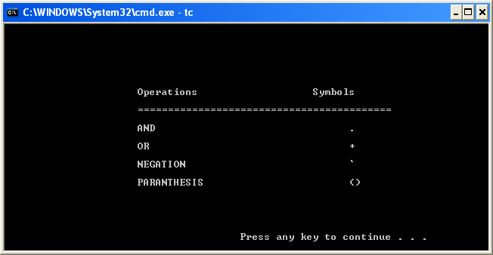

Screen 2:

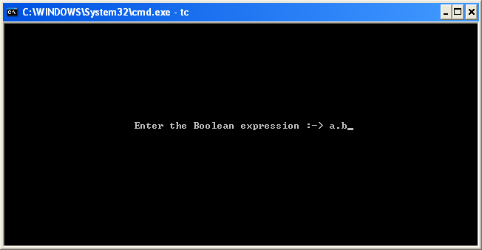

Screen 3:

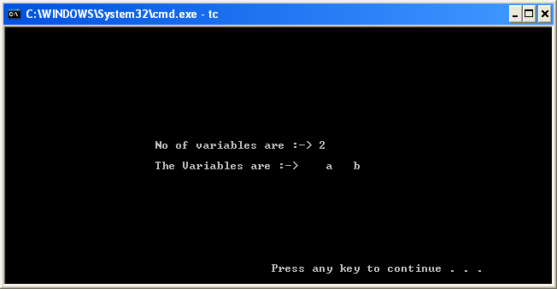

Screen 4:

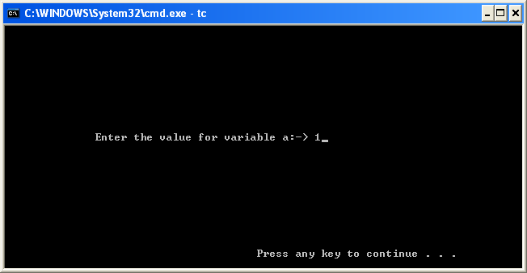

Screen 5:

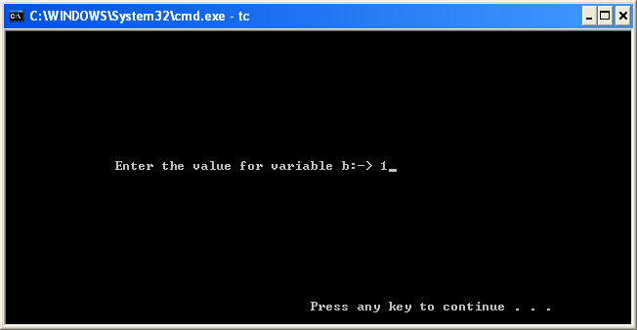

Screen 6:

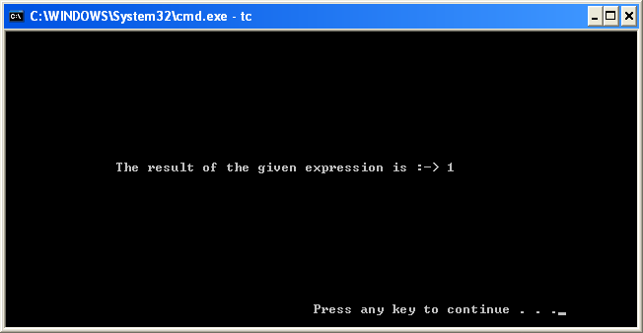

Screen 7:

